

- 2026)
Dr. Jayaram Boga
L. Sainath
2520090148
CSIT
CO-1 Tress & Balanced Search Structures

Case Study Topic: Athlete Performance Management using BST & AVL Trees
Work Done Summary:
In this case study, we implemented athlete profile management using Binary Search Trees (BST) and AVL Trees. Athlete records were indexed using AthleteID to enable efficient insertion, deletion, and search operations. AVL balancing techniques were applied to maintain optimal tree height and ensure O(log n) search performance. Tree traversals were used to generate sorted athlete rankings based on performance records.
Implementation Details:
- Created athlete profiles containing AthleteID, Name, Team, and Performance Score.
- Inserted athlete records into a BST using AthleteID as the key.
- Implemented search functionality to retrieve athlete information efficiently.
- Applied AVL rotations (LL, RR, LR, RL) to maintain balanced trees.
- Performed deletion of athlete records while preserving AVL balance.
- Used inorder traversal to generate sorted athlete rankings.

Result: Screenshot/ Output
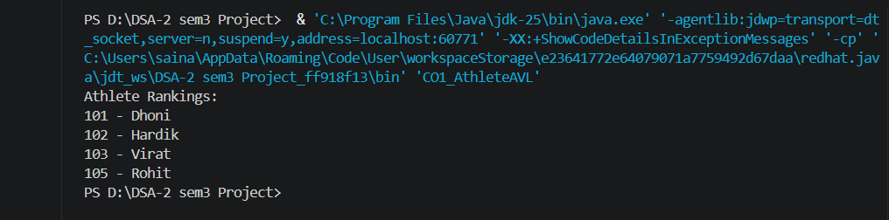
- Athlete records were stored and retrieved efficiently.
- AVL Trees maintained balanced performance even with large datasets.
- Sorted rankings were generated successfully using tree traversals.

Time Complexity:
- Search: O(log n)
- Insert: O(log n)
- Delete: O(log n)
- Traversal: O(n)

GitHub Link: https://github.com/Sainath5689/DSA-2-SEM3-PROJECT

